Lumber Calculator — Open Questions
These items have not yet been confirmed by the broker. Defaults are provided so Claude can build a working MVP without being blocked. Update this file as answers are received, then ask Claude to update the app accordingly.

🔴 High Priority (affects core functionality)
Q1: Nominal vs. Actual Lumber Dimensions
Question: Should the calculator use nominal dimensions (2×4 = 2" × 4") or actual dimensions (2×4 = 1.5" × 3.5")?
Default: Nominal — user enters the size as labeled (e.g., 2, 4). This matches how lumber is bought and sold.
Action if changed: Add a toggle in settings to switch between nominal and actual.
Nominal

Q2: Pricing Unit Preference
Question: Does the broker primarily price in $/MBF, $/BF, or both?
Default: $/MBF (industry standard for volume sales). App will include a toggle to switch to $/BF.
MBF

Q3: Save Calculation History?
Question: Does the broker want to save and recall past calculations on his phone?
Default: No — build as a "calculate and go" tool. Saving can be added in V2.
If yes: Store last 20 calculations in localStorage with timestamp and calculator type.
Calculate and go

Q4: Share / Export Results?
Question: Does the broker need to send calculation results to customers or colleagues?
Default: Add a "Copy to Clipboard" button on each result. No PDF or email needed for MVP.
If yes: Format clipboard text cleanly (e.g., "2×4 × 16' | 100 pcs = 1,066.67 BF @ $850/MBF = $906.67")
That would work!

🟡 Medium Priority (affects UX, not blocking)
Q5: Branding / Business Name
Question: What is the broker's business name and does he have a logo or color preference?
Default: App title = "Lumber Calc", color = forest green (#2D6A4F). Update when info provided.
Don't want to use my company's name. I'm fine with any forest colors. (Tally Calculator/Lumber Calculator)

Q6: Metric Support
Question: Does the broker ever deal in metric units (cubic meters, meters)?
Default: Imperial only (inches, feet, board feet). Metric toggle can be added in V2.
Only Imperial

Q7: Multiple Line Items Per Calculation
Question: Does the broker need to calculate multiple dimensions in one order (e.g., 500 BF of 2×4 + 300 BF of 2×6)?
Default: Single dimension per calculation. User can run multiple calculations separately.
If yes: Add an "Add Line" feature to stack multiple items and sum totals.
Yes for sure. Here is a screenshot of my current calculator. I can do different dimensions and add them up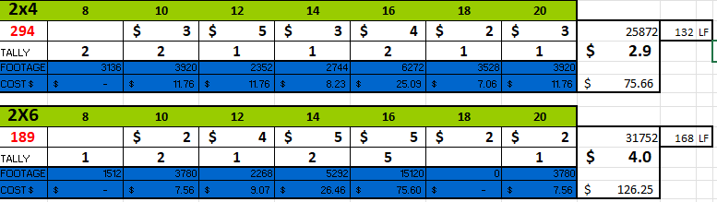

Q8: Truck Load Presets — Are These Accurate?
Question: Are the truck capacity presets (53' = 100,000 BF, 48' = 80,000 BF, Local = 40,000 BF) correct for his typical loads?
Default: Use the values in FORMULAS.md. These are reasonable industry averages but vary by species, dimensions, and carrier.
Note: Always make truck capacity editable so the broker can override.
Truck board footage changes per species. So as long as I can enter freely I can manually know which species I'm after.
I use 2 types of trucks. A “Maxi” and a “Reg”
Maxis can haul 65,000 lbs
Regs can haul 48,000 lbs

🟢 Low Priority (V2 / Nice-to-Have)
Q9: Dark Mode?
Default: Light mode only for MVP.
light
Q10: Species / Grade Reference?
Default: Not included in MVP. Would need a data source for species properties (density, grades, availability).
I have these memorized. But could be fun/nice to have as a tweak we do later
Q11: Job/Customer Tagging?
Default: Not included in MVP. Could be added as a simple text label on saved calculations (requires Q3 = Yes).
Dont need
Q12: Offline Use — How Critical?
Question: Does the broker work in areas with no cell signal (remote lumber yards, rural job sites)?
Default: Build as PWA with offline support regardless — it's a small cost and high value.
Wont need, if im offline then I wont be working

Instructions for Claude
- Build the MVP using all defaults above
- Mark any section in the code with // TODO: [Q#] where a decision point exists
- Make the app modular so features can be toggled on/off as questions get resolved

